**INDEX**

|  |  |  |
| --- | --- | --- |
| SR.NO | CONTENT | PAGE NO. |
| 1. | ACKNOWLEDGEMENT | 2 |
| 2. | MS-EXCEL PROJECT | 3-11 |
| 3. | HTML PROJECT | 12-28 |
| 4. | CONCLUSION | 29 |

1. **ACKNOWLEDGEMENT**

I am obliged to Mrs. Sangita Adak who had inspired me to create these Ms-Excel and HTML projects. Evaluating my interest and urge she encouraged and helped me to complete these projects.

I am indebted to our Head Mistress Mrs. Ivy Sarkar for her constant encouragement in my perseverance.

I would also like to convey my regards to my parents for their guidance and friends for their co-operation which help me to complete the project in time.

**MS-EXCEL**

**PROJECT**

1. Hardware & Software Requirements
2. **Software**
3. Windows Operating System – 98 / 200 Professional / XP / Windows 7
4. Application Software – Microsoft Office Excel 2007 / Notepad etc.
5. **Hardware**
6. PIV or PIII CPU
7. 15-inch Color Monitor [ CRT / LCD ]
8. Mouse
9. Keyboard
10. Printer [ Deskjet or Laserjet]

**B. Aim of MS-Excel Project**

Monthly salaries are paid to all stuff of government & non-government organisations. Salaries differs according to the experience and designation.

So the salary of each employee for each month is to be calculated.

Net salary is calculated from gross salary (Which includes basic pay, DA and of pays) after deducting monthly instalments of loans and different taxes. It is difficult calculate the net salary manually but it become easier to do the same very easy correctly and within a short time using the Spreadsheet. The project is being do keeping in mind this air.

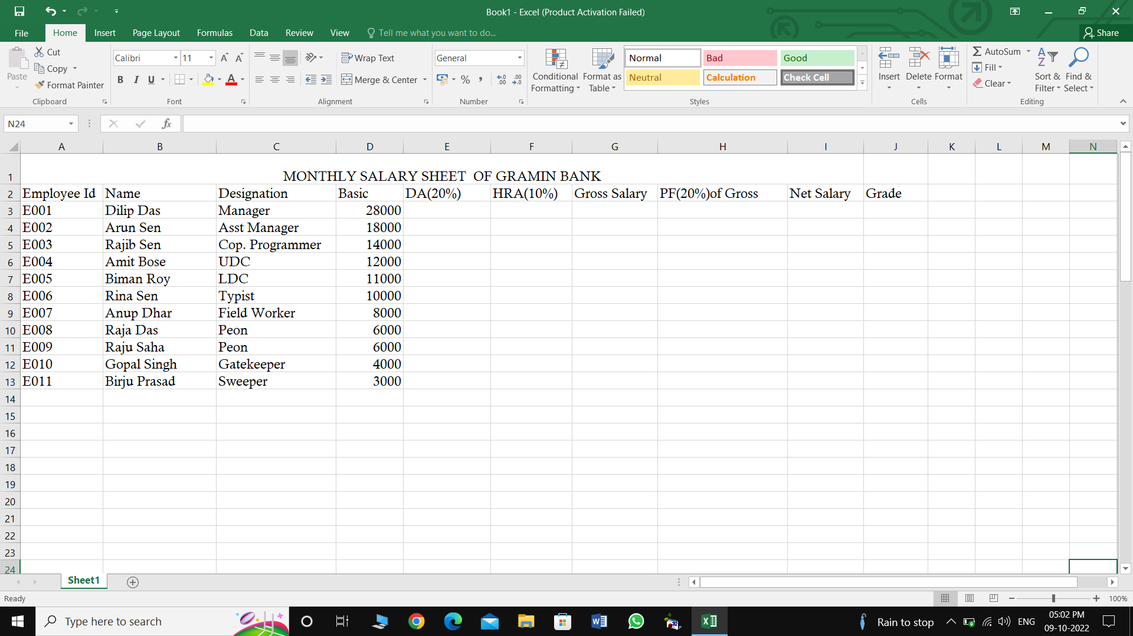

**C. Introduction of Project:**

Experimental Data:

The project that I have done is based in monthly salary sheet of “A GRAMIN BANK” 333The fields are employee’s Name, Designation, Basic Pay, DA, HRA, Gross, PF, NET and GRADE.

**D. The Description of these field are given below :**

1. Employee’s Name: 11 Employee of the Banks are Dilip Das, Arun Sen, Rajib sen, Anil Bose, Biman Roy, Rina Sen…. etc.
2. Designation: Designation of the employees are Manager, Asst. Manager, Cop Programmer, Typist, Peon…. etc.
3. Basic: Basic Salary of each Employees Are Entered this field 20,000, 13,000…. etc.
4. DA (Dearness Allowance): DA is 20% of Basic Salaries 4000, 3600, 2800, 2400, 2200, 2000…. etc.

Formula of DA Calculation: =+D3*20/100

1. HRA (House Rent Allowance): HRA is 10% of Basic Salaries, 2000, 1800, 1400, 1200, 1100, 800…. etc.

Formula of HRA Calculation: =+D3*10/100

1. GROSS: Gross Salaries is calculated from the Total of Basic+DA+HRA.

Formula of Gross Calculation: =+D3+E3+F3

1. PF (Provident Fund): PF is 20% of Gross Salaries 5200, 4680, 3640, 3120…. etc.

Formula of PF Calculation: =+G3*20/100

1. NET: Gross Salaries – PF = Net Salaries, 20800, 18720, 14560…. etc.

Formula of NET Calculation: =+G3-H3

1. Grade: The Condition of Grade are given below:
2. Basic is greater than Rs. 15000 [Basic>15000] is Grade “A”
3. Basic is greater than Rs. 10000 & Less than Rs. 15000 [Basic>10000 and <15000] is Grade “B”
4. Basic is greater than Rs. 5000 & Less than Rs. 10000 [Basic>5000 and <10000] is Grade “C”
5. Basic is Less than Rs. 5000 [Basic<5000] is Grade “D”

Formula of Grade Calculation : =IF(D3>15000,“A”, IF(D3>10000,“B”, IF(D3>5000,“C”, IF(D3<5000,“D”))))

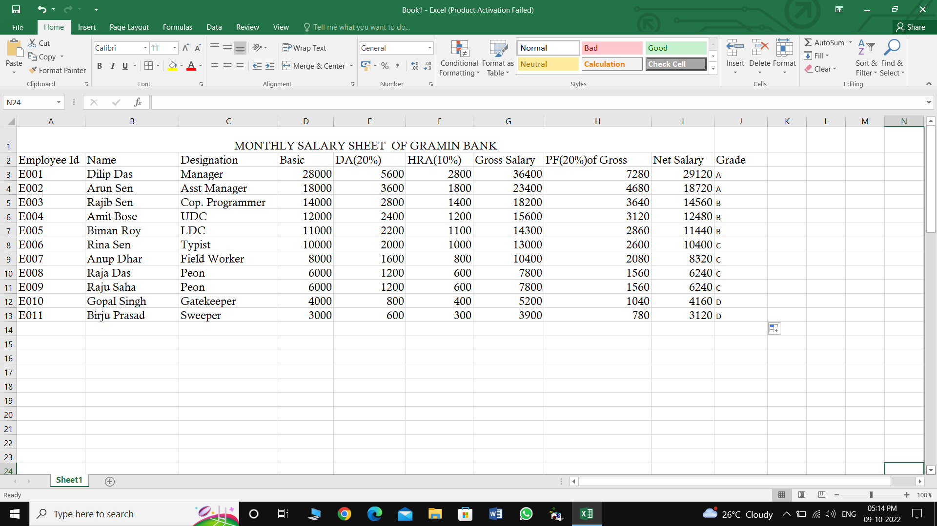

**E. Filtering Procedure**

Select Basic field Click Data ribbon tab Next Click Filter button Filter Arrow button appear Click Filter Arrow button in Basic field Display a list Next click Number Filters Click Greater Than Custom Auto Filter Dialog box appear on the screen

Basic is greater than 15000 Click Ok Button

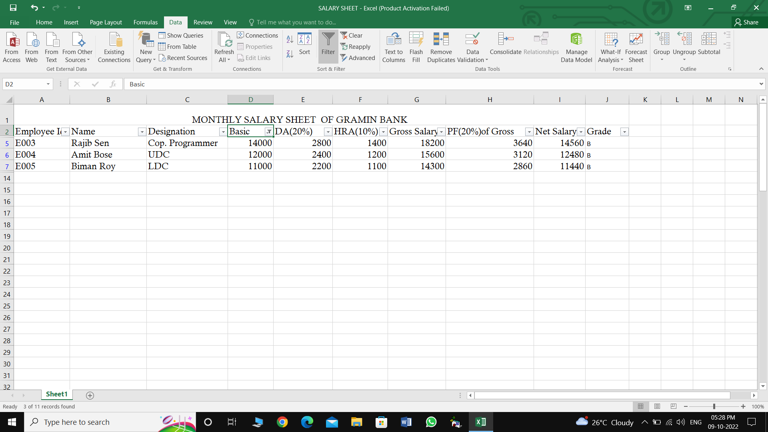

*HTML*

***PROJECT***

1. **Hardware & Software Requirements**
2. Software
3. Windows Operating System – 98 / 200 Professional / XP / Windows 7
4. Application Software – Microsoft Office Excel 2007 / Notepad etc.
5. **Hardware**
6. PIV or PIII CPU
7. 15 inch Color Monitor [ CRT / LCD ]
8. Mouse
9. Keyboard
10. Printer [Deskjet or Laserjet]

**B. Documentation for the Project done On HTML**

The project that I have developed in my computer class is The project that I have developed in my computer class is about Festival in India. He salient information has been electronically notified through five web documents.

The first page is our home page, where only mentioned the definition of Festival and Important Festivals in India.

The respective pages are about the description and images of important Festivals in India which is organised in different locations and by different community in our country.

Entire thing is created upon the hyperlink format so that the user who are yet to see the information can feel very much comfortable, e.g. can open any web page through the Home page displaying the link page where we click to **Go to Next Page** automatically displaying next web page. On the other hand click **Go to Home Page** hypertext to return the to home page.

In the next pages I have described the source code in details and side by side the impression of the screen outputs for each and every web page that has been attached.

The source code for each and every page has been developed through HTML scripting language.

HTML OF HOME PAGE

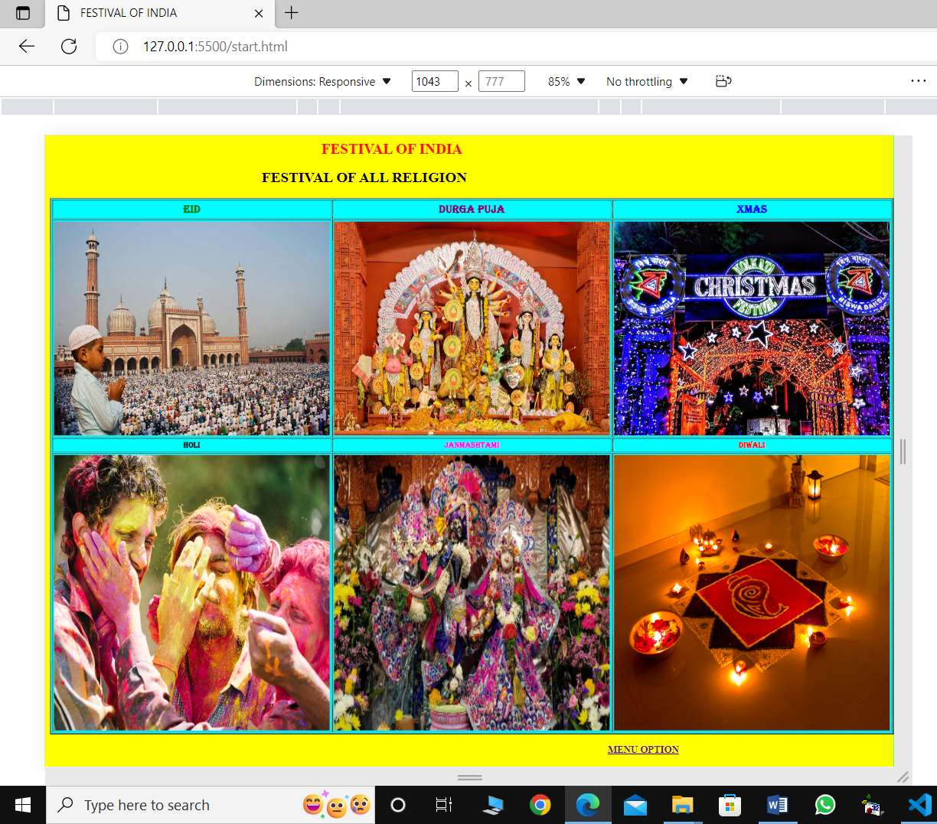

HTML OF HOME PAGE CODE

<html>

  <head>

       <title>FESTIVAL OF INDIA</title>

  </head>

  <body bgcolor="yellow">

       <font size="5" color="red" face="times new roman">

          <MARQUEE DIRECTION="RIGHT"><B>FESTIVAL OF INDIA</B></marquee>

       </font>

        <fontsize="5" color="blue" face="cosmic sans ms">

        <H2><B><CENTER>FESTIVAL OF ALL RELIGION</CENTER></B></H2>

       </font>

       <table border="1" bgcolor="cyan" align="center" cellspacing="2" cellpadding="2">

      <tr>

     <th><font size="4"color="green" face="algerian">Eid</font></th>

    <th><font size="4" color="purple"face="algerian">Durga puja</font></th>

     <th><font size="4" color="blue" face="algerian">Xmas</font></th>

    </tr>

   <tr>

    <td><img src="eidphoto.jpg "height="350"width="450"></td>

     <td><img src= "932320-durgapujads-1.jpg"height="350" width="450"></td>

      <td><img src="xmas.jpeg "height="350" width="450"></td>

   </tr>

  <tr>

   <th><font size="2"color="black"face="algerian">Holi</font></th>

   <th><font size="2" color="magenta"face="algerian">Janmashtami</font></th>

   <th><font size="2" color="red" face="algerian">Diwali</font></th>

   </tr>

  <tr>

  <td><img src="holi.jpg" height="450" width="450"></td>

  <td><img src="janmashtami.jpeg" height="450" width="450"></td>

   <td><img src="diwali.jpg"height="450" width="450"></td>

  </tr>

 </table>

  <P  ALIGN="RIGHT">

   <A HREF=menu.html><B>MENU OPTION</B><A>

</body>

</html>

HTML OF MENU OPTION

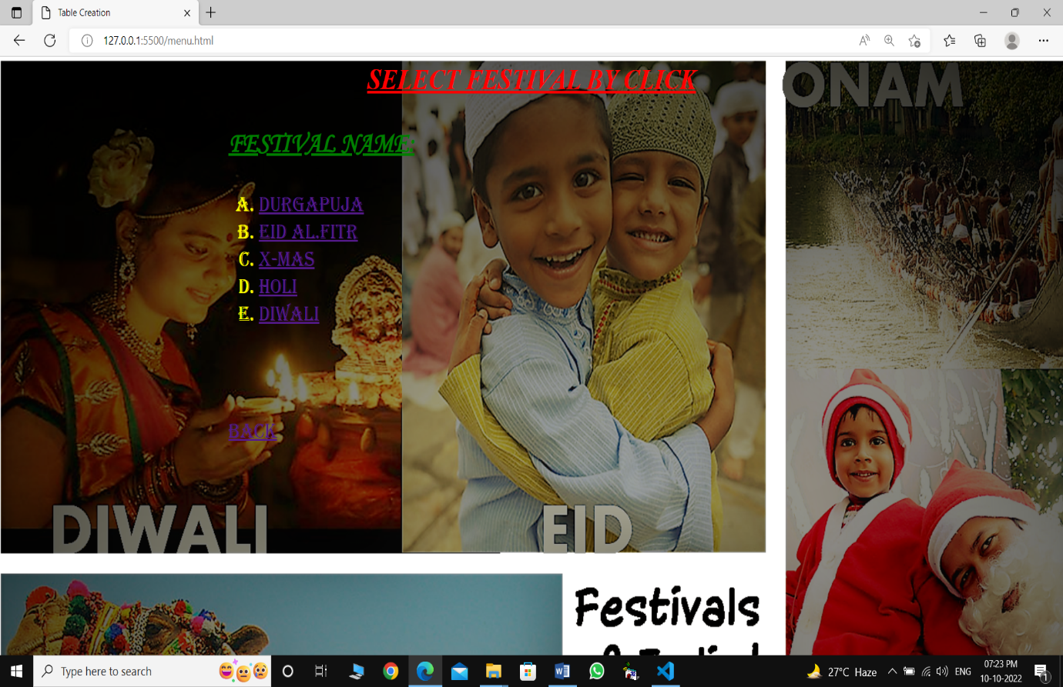

HTML OF MENU CODE

<html>

<head>

<title> Table Creation </title>

</head>

<body BACKGROUND="db26804463d7ed40088d93d227de63d0.png" leftmargin="300">

 <font FACE= "TIMES NEW ROMAN" size="6"color="RED"><center><B><U><I> SELECT FESTIVAL BY CLICK </I></U></B></center></font><BR><BR>

  <B><font FACE="MONOTYPE CORSIVA"size="6"color="green"> <u>FESTIVAL NAME:</u></font></B><BR><BR>

  <ol TYPE="A">

  <font FACE="AlGERIAN"size="5" color="YELLOW">

     <LI><A HREF= durgapuja.HTML>DURGAPUJA</A>

     <font FACE="AlGERIAN"size="5" color="YELLOW">

      <LI><A HREF= eid.HTML>EID AL.FITR</A>

        <font FACE="AlGERIAN"size="5" color="YELLOW">

    <LI><A HREF= xmas.HTML>X-MAS</A>

     <font FACE="AlGERIAN"size="5" color="YELLOW">

     <LI><A HREF= holi.HTML>HOLI</A>

     <font FACE="AlGERIAN"size="5" color="YELLOW">

    <!----<LI><A HREF= janmashtami.HTML>JANMASHTAMI</A>

     <font FACE="AlGERIAN"size="5" color="YELLOW">--->

     <LI><A HREF= diwali.HTML>DIWALI</A>

     </ol>

     <br><br>

     <p align="LEFT">

     <A HREF=start.html>BACK</A>

     </p>

</body>

</html>

HTML OF DURGA PUJA

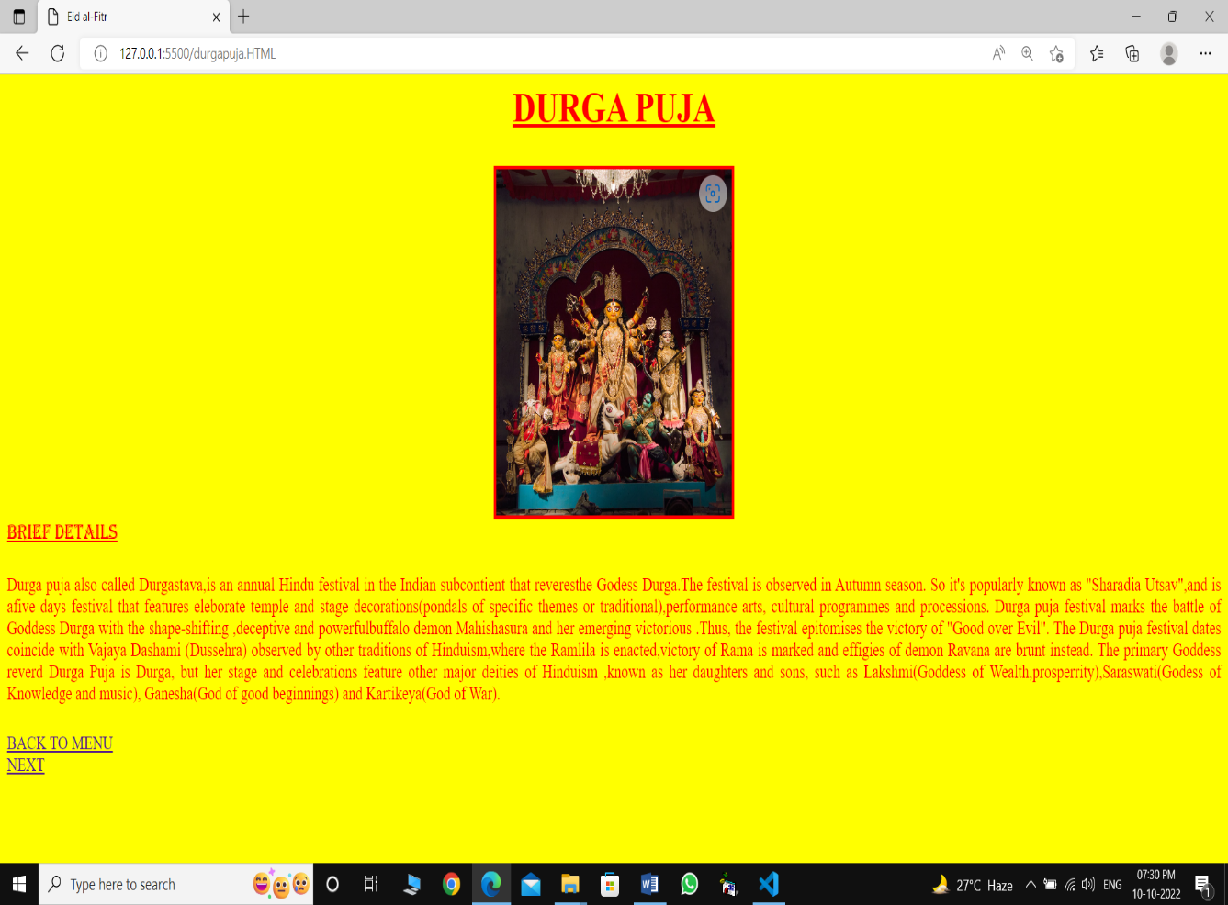

HTML CODE OF DURGA PUJA

<html>

<head>

<title>Durga puja</title>

<body BGCOLOR="Yellow" LEFT MARGIN="500">

<font size="5" color="red" face="times new roman">

<h2><center><B><u>DURGA PUJA</u> </B></center></h2>

<CENTER><img src="durgama.jpg " height="400" width"400" border=5></CENTER>

<FONT FACE="ALGERIAN" size="4" COLOR="RED"><U>BRIEF DETAILS</U></FONT>

<P ALIGN="JUSTIFY">

<font size="3" color="RED" face="times new roman">

Durga puja also called Durgastava,is an annual Hindu festival in the Indian subcontient that reveresthe Godess Durga.The festival is observed in Autumn season.

So it's  popularly known as "Sharadia Utsav",and is afive days festival that features eleborate temple and stage decorations(pondals of specific themes or traditional),performance arts, cultural programmes and processions.

Durga puja festival marks the battle of Goddess Durga with the shape-shifting ,deceptive and powerfulbuffalo demon  Mahishasura and her emerging victorious .Thus, the festival epitomises the victory of "Good over Evil".

The Durga puja festival dates coincide with Vajaya Dashami (Dussehra) observed by other traditions of Hinduism,where the Ramlila is enacted,victory of Rama is marked and effigies of demon Ravana are brunt instead.

The  primary Goddess  reverd Durga Puja is Durga, but her stage and celebrations feature other major deities of Hinduism ,known as her daughters and sons, such as Lakshmi(Goddess of Wealth,prosperrity),Saraswati(Godess of Knowledge and music),

Ganesha(God of  good beginnings) and Kartikeya(God of War).

</P>

<A HREF=menu.html>BACK TO MENU</A><br>

<A HREF=eid.html>NEXT</A>

</BODY>

</html>

HTML OF EID-AL FITAR

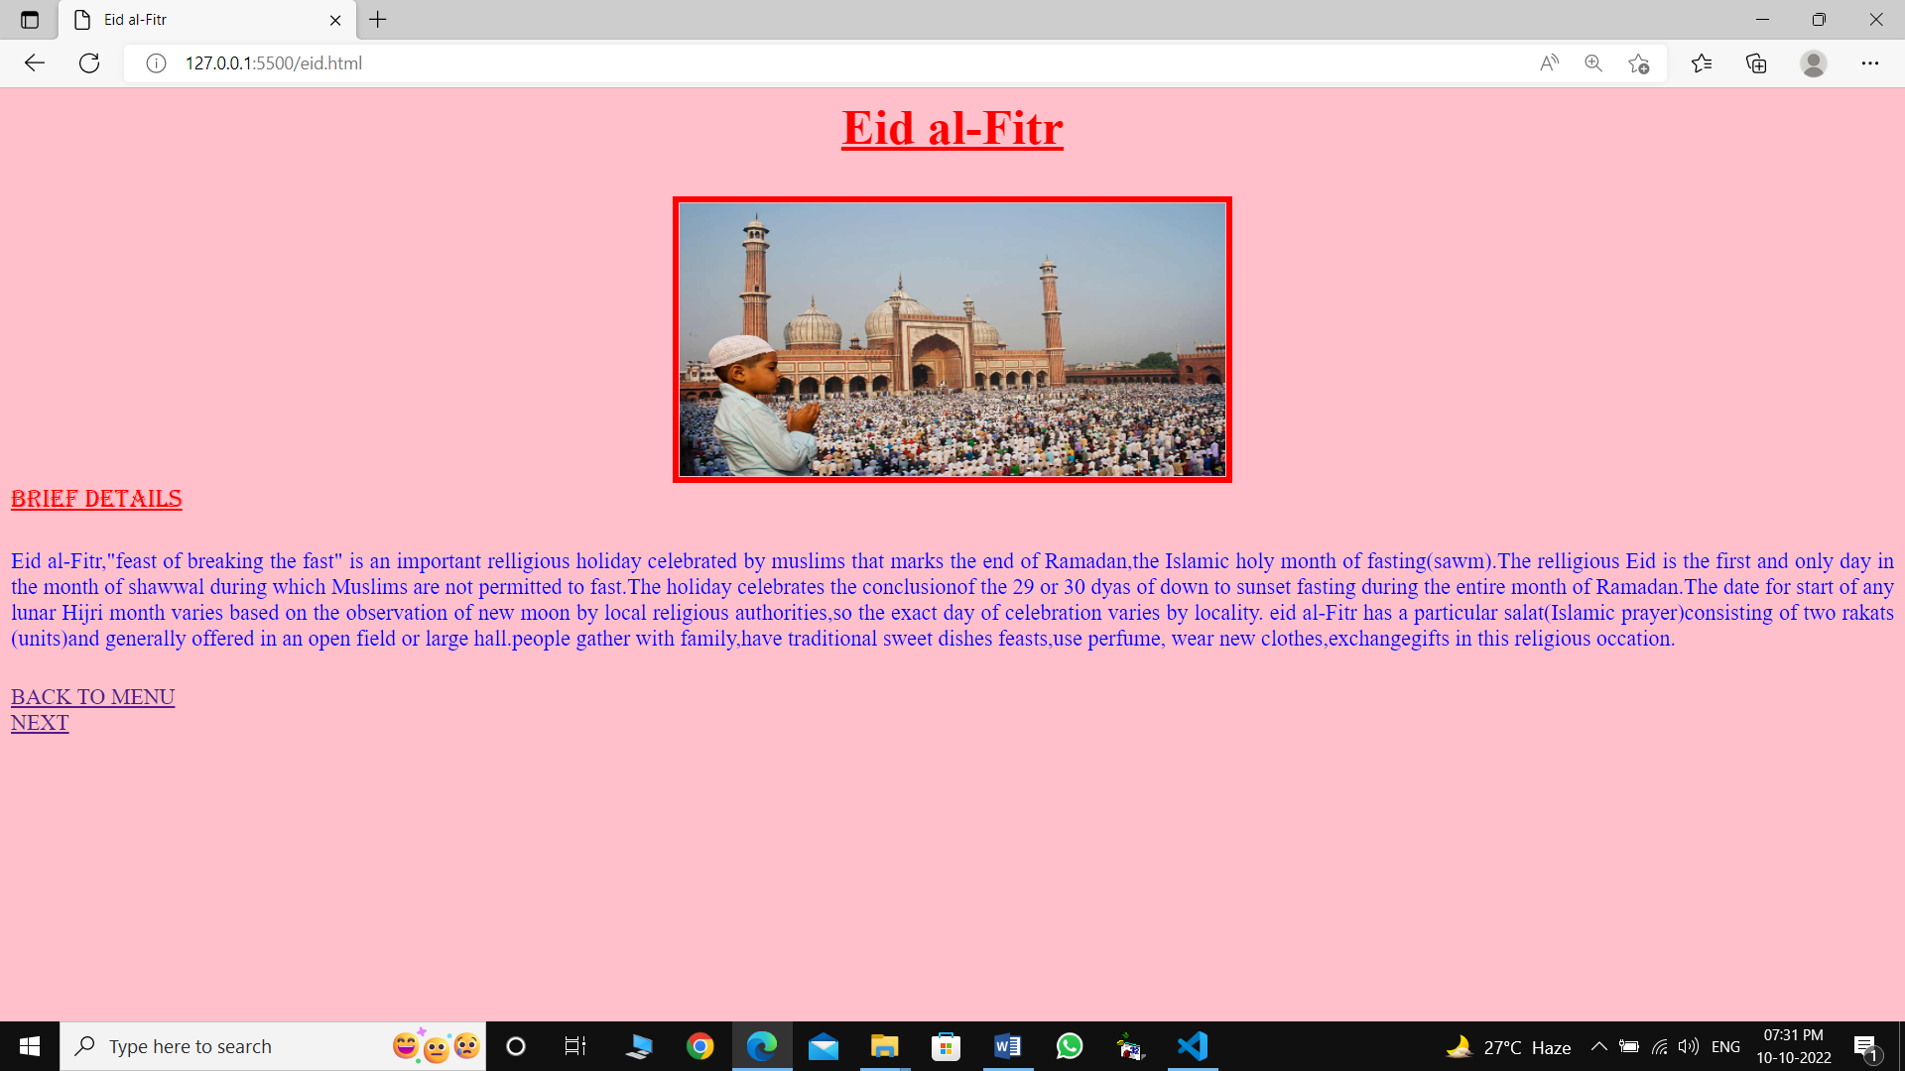

HTML CODE OF EID-AL FITAR

<html>

<head>

<title>Eid al-Fitr</title>

<body BGCOLOR="pink" LEFT MARGIN="500">

<font size="5" color="red" face="times new roman">

<h2><center><B><u>Eid al-Fitr</u></B></center></h2>

<CENTER><img src="  eidphoto.jpg   "   height="200" width="400" border=5></CENTER>

<FONT FACE="ALGERIAN" size="4" COLOR="RED"><U>BRIEF DETAILS</U></FONT>

<P ALIGN="JUSTIFY">

<font size="3" color="BLUE" face="times new roman">

Eid al-Fitr,"feast of breaking  the fast" is an important relligious holiday celebrated by muslims that marks  the end of Ramadan,the Islamic holy  month of fasting(sawm).The relligious Eid is the first and only day in the month of shawwal during which Muslims are not permitted to fast.The holiday celebrates the conclusionof the 29 or 30 dyas of down to sunset fasting during the entire month of Ramadan.The date for start of any  lunar Hijri month varies based on the observation of new moon by local religious authorities,so the exact day of celebration varies by locality.

eid al-Fitr has a particular salat(Islamic prayer)consisting of two rakats (units)and generally offered in an open field or large hall.people gather with family,have traditional sweet dishes feasts,use perfume, wear new clothes,exchangegifts in this religious occation.

</P>

<A HREF=menu.html>BACK TO MENU</A><br>

<A HREF=Xmas.HTML>NEXT</A>

</BODY>

</html>

HTML OF CHRISTMAS

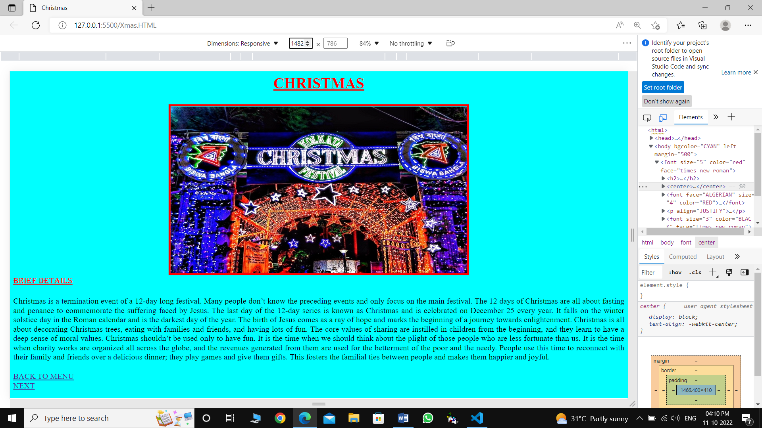

HTML CODE OF CHRISTMAS

<html>

<head>

<title>Christmas</title>

<body BGCOLOR="CYAN" LEFT MARGIN="500">

<font size="5" color="red" face="times new roman">

<h2><center><B><u>CHRISTMAS</u> </B></center></h2>

<CENTER><img src="xmas.jpeg " height="400" width"500" border=5></CENTER>

<FONT FACE="ALGERIAN" size="4" COLOR="RED"><U>BRIEF DETAILS</U></FONT>

<P ALIGN="JUSTIFY">

<font size="3" color="Black" face="times new roman">

Christmas is a termination event of a 12-day long festival. Many people don’t know the preceding events and only focus on the main festival. The 12 days of Christmas are all about fasting and penance to commemorate the suffering faced by Jesus.

The last day of the 12-day series is known as Christmas and is celebrated on December 25 every year. It falls on the winter solstice day in the Roman calendar and is the darkest day of the year. The birth of Jesus comes as a ray of hope and marks the beginning of a journey towards enlightenment. Christmas is all about decorating Christmas trees, eating with families and friends, and having lots of fun. The core values of sharing are instilled in children from the beginning, and they learn to have a deep sense of moral values.

Christmas shouldn’t be used only to have fun. It is the time when we should think about the plight of those people who are less fortunate than us. It is the time when charity works are organized all across the globe, and the revenues generated from them are used for the betterment of the poor and the needy. People use this time to reconnect with their family and friends over a delicious dinner; they play games and give them gifts. This fosters the familial ties between people and makes them happier and joyful.

</P>

<A HREF=menu.html>BACK TO MENU</A><br>

<A HREF=Holi.HTML>NEXT</A>

</BODY>

</html>

HTML OF HOLI

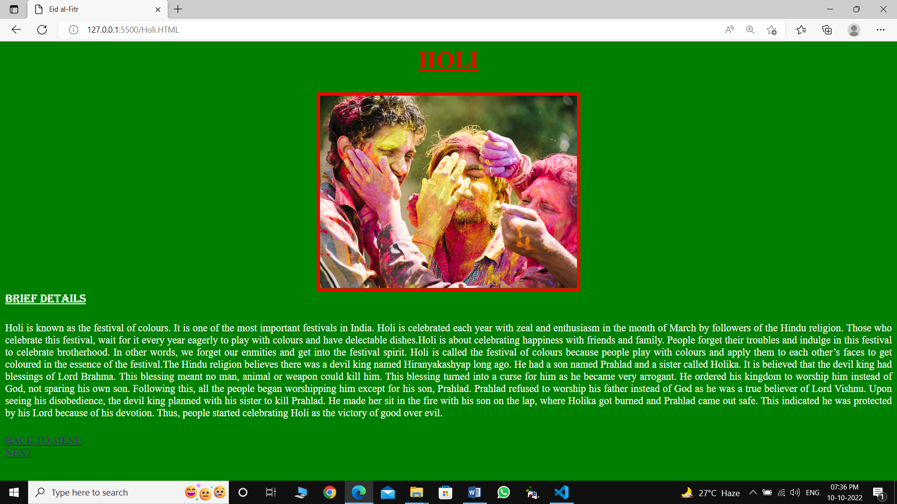

HTML CODE OF HOLI

<html>

<head>

<title>Holi</title>

<body BGCOLOR="green" LEFT MARGIN="500">

<font size="5" color="red" face="times new roman">

<h2><center><B><u>HOLI </u></B></center></h2>

<CENTER><img src=" holi.jpg" height="400" width"500" border=5></CENTER>

<FONT FACE="ALGERIAN" size="4" COLOR="white"><U>BRIEF DETAILS</U></FONT>

<P ALIGN="JUSTIFY">

<font size="3" color="WHITE" face="times new roman">

Holi is known as the festival of colours. It is one of the most important festivals in India. Holi is celebrated each year with zeal and enthusiasm in the month of March by followers of the Hindu religion. Those who celebrate this festival, wait for it every year eagerly to play with colours and have delectable dishes.Holi is about celebrating happiness with friends and family. People forget their troubles and indulge in this festival to celebrate brotherhood. In other words, we forget our enmities and get into the festival spirit. Holi is called the festival of colours because people play with colours and apply them to each other’s faces to get coloured in the essence of the festival.The Hindu religion believes there was a devil king named Hiranyakashyap long ago. He had a son named Prahlad and a sister called Holika. It is believed that the devil king had blessings of Lord Brahma. This blessing meant no man, animal or weapon could kill him. This blessing turned into a curse for him as he became very arrogant. He ordered his kingdom to worship him instead of God, not sparing his own son.

Following this, all the people began worshipping him except for his son, Prahlad. Prahlad refused to worship his father instead of God as he was a true believer of Lord Vishnu. Upon seeing his disobedience, the devil king planned with his sister to kill Prahlad. He made her sit in the fire with his son on the lap, where Holika got burned and Prahlad came out safe. This indicated he was protected by his Lord because of his devotion. Thus, people started celebrating Holi as the victory of good over evil.

</P>

<A HREF="menu.html">BACK TO MENU</A><br>

<A HREF=Diwali.html>NEXT</A>

</BODY>

</html>

HTML OF DIWALI

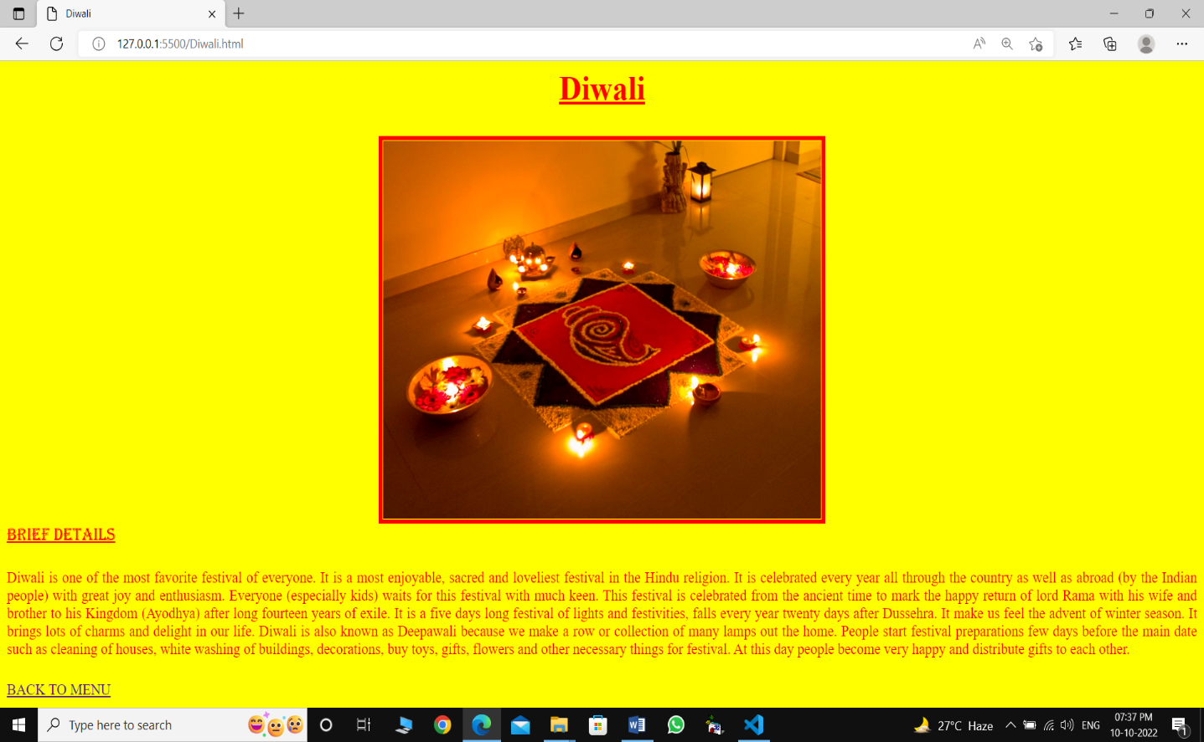

HTML CODE OF DIWALI

<html>

<head>

    <title>Diwali</title>

</head>

    <body BGCOLOR="Yellow" LEFT MARGIN="500">

        <font size="5" color="red" face="times new roman">

        <h2><center><B><u>Diwali</u></B></center></h2>

        <CENTER><img src="diwali.jpg" height="400" width"500" border=5></CENTER>

        <FONT FACE="ALGERIAN" size="4" COLOR="RED"><U>BRIEF DETAILS</U></FONT>

        <P ALIGN="JUSTIFY">

        <font size="3" color="RED" face="times new roman">

            Diwali is one of the most favorite festival of everyone. It is a most enjoyable, sacred and loveliest festival in the Hindu religion. It is celebrated every year all through the country as well as abroad (by the Indian people) with great joy and enthusiasm. Everyone (especially kids) waits for this festival with much keen. This festival is celebrated from the ancient time to mark the happy return of lord Rama with his wife and brother to his Kingdom (Ayodhya) after long fourteen years of exile.

            It is a five days long festival of lights and festivities, falls every year twenty days after Dussehra. It make us feel the advent of winter season. It brings lots of charms and delight in our life. Diwali is also known as Deepawali because we make a row or collection of many lamps out the home. People start festival preparations few days before the main date such as cleaning of houses, white washing of buildings, decorations, buy toys, gifts, flowers and other necessary things for festival. At this day people become very happy and distribute gifts to each other.

        </P>

        <A HREF=menu.html>BACK TO MENU</A>

        </BODY>

        </html>

**4.Conclusion**

I have tried my best to complete my MS-Excel and HTML project works successfully amidst a amicable ambience of constant co-operation & remarkable assistance. Varied tasks may be performed through various modules for easy accessibility. However, this recently developed system may not provide all sorts of facilities. Although there was no lack of endeavour on my part to develop this system but it is quite possible that there may be some potentials to develop it further which may due to lack of front-end application.

In spite of all adversities I am elated to be able to complete these projects gathering huge experience in the process which will certainly help me in future.